NOTES: OCEAN ECOLOGY AND ENERGY TRANSFER NAME _____________________Hr__

______________- the study of how organisms _______________ with each other and the environment

What is an ecosystem?

_______________ – all the _______________ and _______________ factors in a particular environment

Biotic- _______________

Abiotic- _______________ -_______________ (_______________, _______________, _______________, _______________, _______________, _______________, etc.)

What are the _______________ (jobs organisms have) in ecosystems?

Primary _______________

the _______________ source of food in the ecosystem

All other life _______________ on primary _______________

they have the greatest _______________ in the community

the greatest amount of _______________ is found in the producers

Primary _______________

get their energy _______________ from the primary producers by _______________

get their energy _______________ by living _______________ with them

_______________ order _______________

prey on the primary consumers and in turn are _______________ by other animals

_______________ order _______________

eat other _______________ and _______________ but are rarely _______________ by other creatures

have the _______________ biomass in the community

have the _______________ amount of _______________ in their tissues

What are the 2 main categories of marine ecosystems?

Powered by _______________ (_______________ energy source)

Occurs in the top 2 ocean zones—the _______________ and the _______________

_______________ fully penetrates the epipelagic, but only dimly lights the mesopelagic

The presence of sunlight allows for _______________

The bottom of the food chain is therefore _______________, microscopic organisms that can do _______________.

Powered by Earth’s _______________ (_______________ energy source)

Occurs in the bottom 3 ocean zones – the _______________, _______________, & _______________

No _______________ penetrates at all

No _______________ is possible

No _______________ can grow here

No _______________ can grow here, but there is _______________, microscopic organisms that are _______________

The bottom of the food chain is _______________ _______________

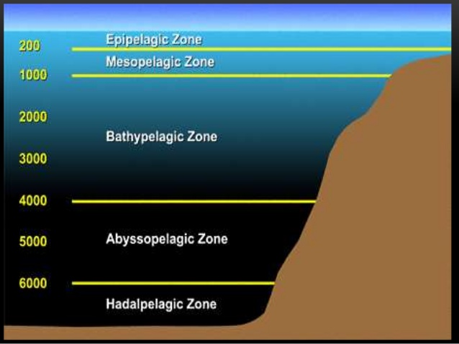

What are the Symbiotic _______________?

_______________ beneficial- _______________ species benefit

_______________ - 1 species _______________, and the other is _______________ (or doesn’t care)

_______________ – 1 species _______________, but the other is _______________

How is energy flow diagramed?

_______________ _______________ - a simple diagram showing how a single chain of organisms pass their _______________ into each other

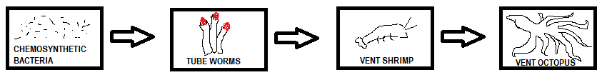

_______________ _______________ - a complex diagram showing the many ways _______________ flows between _______________

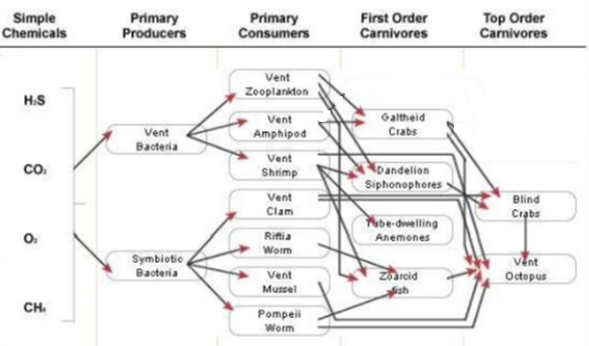

_______________ _______________ - a diagram that shows amounts of _______________ and _______________ numbers in an ecosystem

The bottom of the pyramid is wide because

the lowest trophic level has the _______________ _______________

the lowest trophic level has the _______________ amount of _______________

the pyramid gets thinner as it rises showing

_______________ populations

energy _______________ with every level jump

the _______________ level is smallest because

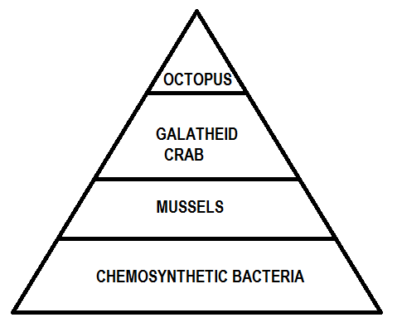
it has the _______________ _______________

it has the _______________ amount of _______________

