ENERGY PYRAMID ACTIVITY /44 name _________________________ hr__
BACKGROUND INFORMATION:
HYDROTHERMAL VENTS are a crack or breakage in the earth’s surface. Seawater seeps in the cracks on the ocean floor and the magma underneath the tectonic plates heats the water and forces it upwards. When in the earth, the hot water dissolves minerals and chemicals. Once it emerges is contains a “food” source for the chemosynthetic bacteria. The bacteria “eat” toxic chemical gases and transform them into (food) sugar. The bacteria are the PRODUCERS in this ecosystem. If it were not for them, nothing could exist at the bottom of the ocean near these vents.
INSTRUCTIONS:
You have been given 13 cards with information about organisms that live at hydrothermal vents. Your task is to sort the cards into 4 different trophic levels. The bottom level in this ecosystem is the chemosynthetic bacteria.

- Primary producers are the original source of food in the vent ecosystem, using chemical energy to create organic molecules. All other life depends on primary producers, and they have the greatest biomass in the community.

- Primary consumers get their energy directly from the primary producers by eating or living symbiotically with them.

- First order carnivores prey on the primary consumers and in turn are eaten by other animals.

- Top order carnivores eat other consumers and carnivores but are rarely hunted by other creatures. Because they are separated from the primary food production by several layers, top order carnivores have the smallest biomass in the food web.

One creature will be hard to place in this pyramid. Write its name in the box.

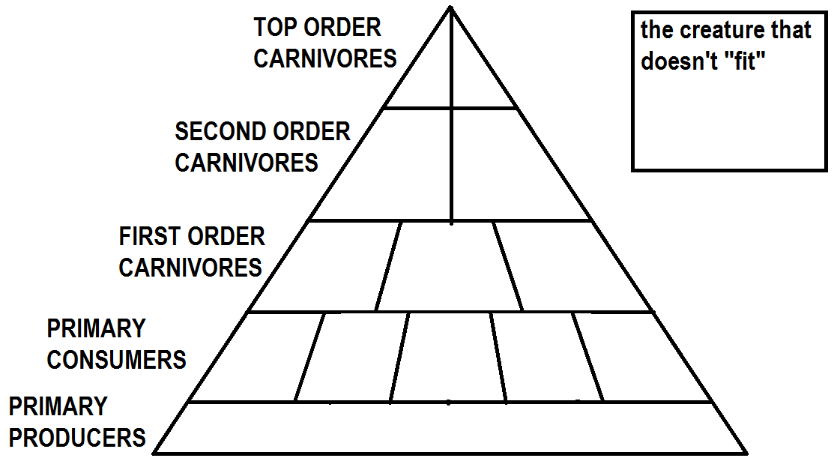
- The chemosynthetic bacteria in this ecosystem use hydrogen sulfide to make sugars, but what provided the energy for the hydrogen sulfide to “get married” in the first place?

- How does the water in the hydrothermal vent get heated? (as it seeps into the crack what does it get next to?)
- Ultimately, where does the heat energy in the magma come from?
- What does it mean to be in a parasitic symbiotic relationship?
- What does it mean to be in a mutually beneficial symbiotic relationship?
- What are zooplankton?
- What types of organisms are the zooplankton down here made of?
- Why are there no phytoplankton species down here?
- Which 2 species don’t really “eat” their food, because their food is made for them right in their bodies through a symbiotic relationship? 1 2

- Which creature is not 1 creature, but a colony of many organisms working together?
- What is a creature called if it has to EAT its food?
- What is a creature called if it is an eater of other eaters?
- What is a creature called if it eats dead stuff?
- How does a mussel move since it has no legs, fins, or tentacles?
- Why do you think the octopus doesn’t bother to have an ink sac?
- If a species is blind, how do you think it will it find its food?
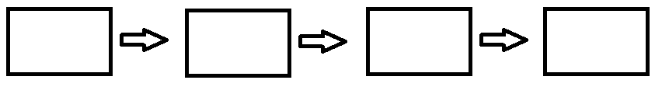
- Draw 2 food chains that exists in this ecosystem (8 pts)

- Every time energy moves from one creature into another, some of that energy is “lost” because it is converted into other formats. In which level would most of the energy be found?

- Energy pyramids are smaller at the top to represent not just the amount of energy found at each level, but also the population numbers at each level. Which creatures in this ecosystem would be found in the fewest numbers?

- Which creatures would be most numerous?
- If you were to count the energy calories in all the octopuses, would there be more calories or less calories than what would be found in all the tubeworms?

- Where should the creature that “didn’t fit” be categorized?

