Ocean Water Density Lab /17 Name: ______________________ Hr_____

Scientific Question:
How does salinity and temperature effect the ocean water’s density?

Hypothesis: You will be writing two hypotheses. The first will concern the effect that salinity has on ocean water density. The second will concern the effect that temperature has on ocean water density.

1.___________________________________________________________________________________

_____________________________________________________________________________________

2.___________________________________________________________________________________

_____________________________________________________________________________________

Testing Your Hypotheses: Procedure (Observations should be made from the side, not from above)
PART ONE
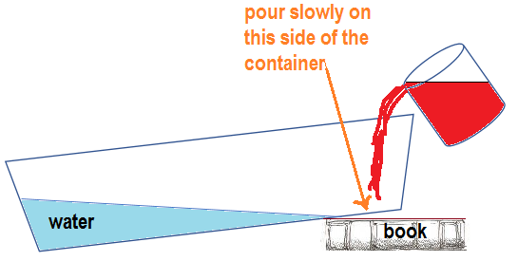
- Fill a deep, clear plastic container ¾ full, with room temperature water. Using your textbook, set your container down on an angle. Let it rest until it’s still.
- In a beaker, mix 100 mL of room temperature water, ½ tbsp. of table salt, and add 3 drops of red food coloring. Stir the mixture until the salt is dissolved.
- Slowly add the red saltwater mixture to the water in the clear plastic container while looking at it sideways. Do not try to make an observation by looking straight down into the water.

DATA: (record your observation)

_____________________________________________________________________________________

_____________________________________________________________________________________

PART TWO:
- Repeat step one above
- In a beaker, add 3 drops of blue food coloring with 100 mL of ice water.
- Slowly add the cold, blue water to the clear plastic container. Record your observations from the side once again.

DATA: (record your observation)

_____________________________________________________________________________________

_____________________________________________________________________________________

Analysis:
- Describe what happened when you added the red salt water to the fresh water.

_____________________________________________________________________________________

- Which is more dense -- fresh water or salt water? __________________________

- What happened when you added the cold water to the room temperature water?
_____________________________________________________________________________________

- Which is more dense -- cold water or room temperature water? __________________________

- What would you expect to happen if the blue water was heated, instead of cooled?
_____________________________________________________________________________________

- Based on your observations, where would you expect the water in the ocean to be the least dense?
_____________________________________________________________________________________

- …the most dense?
_____________________________________________________________________________________

- Describe water layering where a river empties into the ocean. (To answer this, think about the depth of a river versus the depth of an ocean, and how the sun’s heat affects each. Also, think about the difference between salt and fresh water.) (2pts)

_____________________________________________________________________________________

_____________________________________________________________________________________

Argument with Evidence: You will need 2 arguments supported by evidence. One statement should be about salinity and its effect on ocean water’s density, the other should be about temperature and its effect on ocean water’s density. (4 points- claim + evidence 2 times)

1. ___________________________________________________________________________________________

_____________________________________________________________________________________________

2. ___________________________________________________________________________________________

_____________________________________________________________________________________________

EXTRA credit:

What would happen if you mixed the salt water and the cold water together? Describe the result.
(Try it if you want to.)

____________________________________________________________________________________________
Is there any way you could get a different result than the one you just wrote down?

____________________________________________________________________________________________

