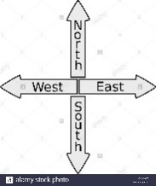
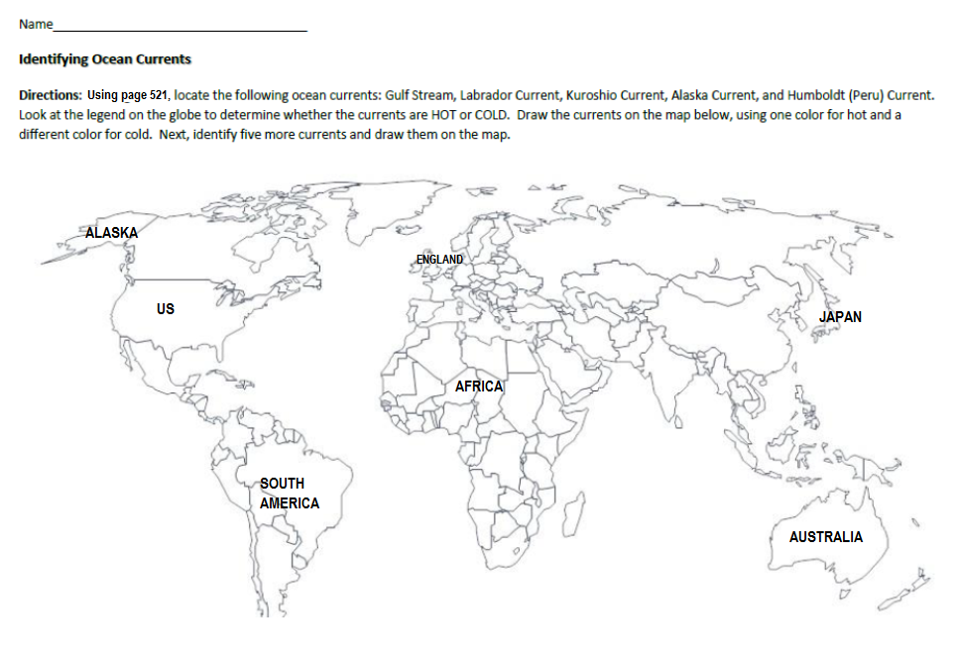
IDENTIFYING OCEAN CURRENTS ACTIVITY /23
NAME _________________________HR____
1. Why is the water off the coast of North East Canada cooler than off the coast of Florida?

2. Why is England, which is located further north latitude than Michigan, warmer than us?

3. Why does England get a lot of rain? (Hint: does warmer water or colder water evaporate more?)

4. Why is southern Alaska warmer than it should be?

5. Why is western Australia cooler than Eastern Australia?

6. Why is it warmer on the east side of south America than on the west side?

7. Why is the Scandinavian Peninsula (NE of England) warmer than it is supposed to be?

8. Why is it warmer on the East side of South Africa than on the West side?

9. Why is North West Africa cooler than it should be?

10. By looking at the currents, why did early sailing explorers from European countries sail south before sailing west to the New World (US, Canada, etc.) and then North before sailing East back to Europe?

11. Before the Panama Canal was built in Central America, why was it difficult and slow going for ships to travel from the Atlantic Ocean West around the tip of South America to get to the Pacific?

12. When the North Atlantic current splits, the north east arrow stays red, while the Canary current that goes south becomes blue. Why, if the water is head toward the equator where it is warmer, it the water cooler as it goes past the northeast coast of Africa? (Use your knowledge from the powerpoint)

13. The North Pacific current splits in two as it reaches land, ½ going north and half going south. If the north one stays warm, (the one becoming the Alaska current) why doesn’t the California current also stay warm? It is heading south toward the warmth of the equator, yet it is a cold current. Why?

