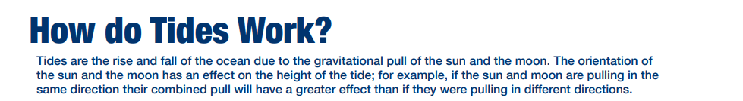
NAME ________________________________________HR__ /49
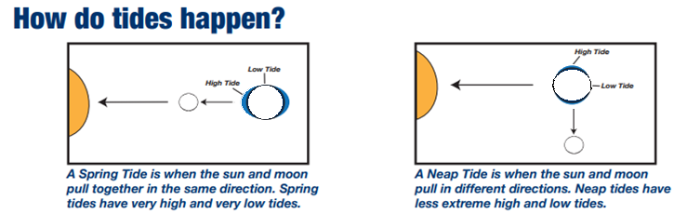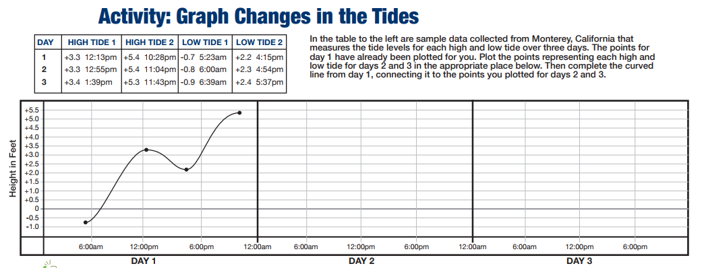
- Based on the previous graph, high tides happen how many times per day?
- Based on the previous graph, low tides happen how many times per day?
- How many minutes later did the high tide 1 occur from day 1 to day 2?
- What type of tide is shown in the above graphing exercise?

 | Force that attracts all objects with mass towards one another | A | Tidal range
 | Difference between high tide and low tide | B | Tide
 | Pulls on the water in oceans twice as much as the sun | C | Neap tide
 | When high tides are lower and low tides are higher than normal | D | Moon
 | Movement in which water in a lake or ocean rises and falls | E | Spring tide
 | When the high tides are higher and low tides are lower than normal | F | gravity

- Draw the shape of the water around Earth for each diagram and color in blue (4 pts)
- Draw force arrows showing how the water is pulled (2 arrows on each picture- 8 pt total)
- Properly shade the moon in each picture (4 pts)
- What type of tide? | - What type of tide?
- Which lunar phase? | - Which lunar phase?
- What type of tide? | - What type of tide?
- Which lunar phase? | - Which lunar phase?

- What causes the water opposite of the moon to also have a bulge?
- Why are low tides low?
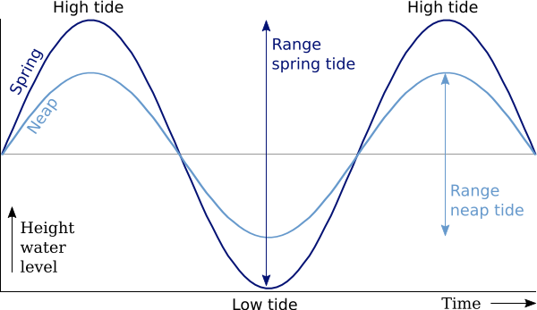

- According to the graph, which type of tide has a greater tidal range?
- Why do spring tides have higher high tides?

