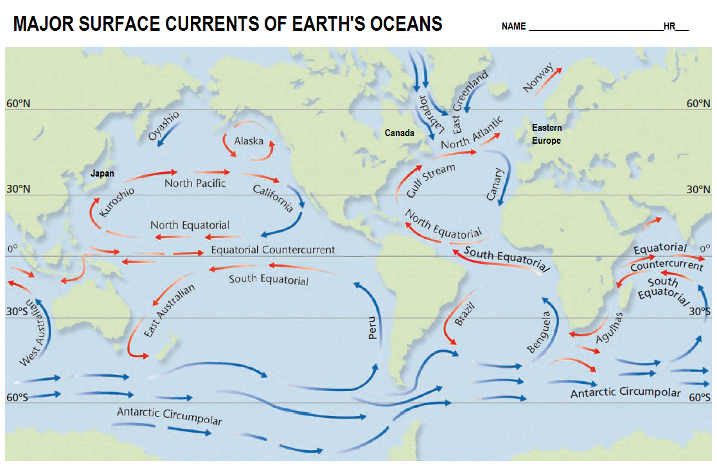
MAJOR SURFACE CURRENTS OF OUR OCEANS NAME __________________________ HR__

- Using a red and blue pencil, label each current arrow as either cold (blue) or red (warm)
- What 3 things influence the currents in our oceans? (p 519)
1
2
3
- Why does the North pacific current head straight for America, but then bend south and to the right?
- In yellow pencil draw arrows indicating the Northern Hemisphere gyre in the Atlantic.
- In green pencil draw arrows indicating the Southern Hemisphere gyre in the Atlantic.
- How does the direction of current flow differ in the northern and southern hemispheres?
- The North equatorial and South Equatorial both move what direction?
- What weak current flows between and opposite to these currents?
- What relationship does the North Equatorial have with the gulf stream?
- Why does Northwestern Europe have a far warmer climate than regions of Canada at the same latitude?
- When the Oyashio comes Southwest and hits Japan, what current will it likely join? How will its temperature change? How will it’s direction change?
1
2
3
- Which current can go all the way around the Earth without interruption?
- Why are all equatorial currents warm?
- In general, cold currents (blue) coming from Antarctica become warm (red) as they move north. Why?

