**I EVIDENCE OF THE PAST 6-1 name ________________hr_**

A **Fossils**- a trace or imprint of living things that are preserved in rock

1] **Relative dating**- any method of determining whether an event or object is older or younger than other events or objects

2] **Absolute dating** — a method of measuring the age of fossils in years

a) **Radiometric dating** — using radioactive elements' 1/2 life to come up with a date range

b) Types – radio carbon, uranium- lead, potassium argon

B **Geologic time scale** — the standard method used to divide earth's long natural history into manageable parts based on significant events (like extinction, appearance of new organism, formation of mountain chains or oceans, ice age, or widespread volcanic eruptions.)

1] **Era** — major time division (4)

a) **Precambrian**

b) **Paleozoic**

c) **Mesozoic**

d) **Cenozoic**

2] **Period**- a division of an era

3] **Epoch**- a division of a period

C The changing Earth

1] **Pangaea** — all continents formed one landmass ("all earth")

2] **Plate tectonics** — large pieces of earth's crust "float" moving the continents around over time

3] Rapid changes- create **extinctions** (species dying out)

4] Slow changes — allow for **adaptations** (animals changing to survive)

**II ERAS OF GEOLOGIC TIME 6-2**

A **Precambrian**- 4,600 mya — 543 mya (4.6Bya-543mya)

1] 4600 million years ago Earth forms

2] 3800 million years ago crust hardens

3] 3500 million years ago = first **prokaryotic** (no nucleus) life forms

a) single-celled, **photosynthetic** (make food from the sun), cyanobacteria

b) released 02 into atmosphere

c) created ozone layer (03) which blocked UV rays

4] 2500 m.y.a

a) first **eukaryotic** (nucleus and other organelles) life forms

b) animal like (ate their food) like an amoeba

5] Ended with explosion of multicellular ocean life (Cambrian explosion)

B **Paleozoic** — ("ancient life") 543 -248 mya

1] Sponges, corals, snails, clams, squid, trilobites, fish, sharks

2] Ferns, club moss, horsetails, and conifers appear on land toward the end of era

3] Wingless insects, salamander-like amphibians during middle, followed by winged insects and reptiles by the end of the era

4] Ends in largest mass extinction in history (90% of all species because of ice age?)

C **Mesozoic** (middle life) 248 -65 mya

1 "Age of reptiles"

2 Dinosaurs dominate for 150 million years

3 Pangaea broke up

4 Dinosaurs, mammals, birds, flowers

5 Ended with mass extinction 65 m.y.a. (asteroid)

D **Cenozoic**- 65mya- present

1 Age of mammals

2 Horse, monkeys, whales, cats, bears, hominids, humans, mammoths, sabertooth

3 Several ice ages (glaciers)

**III HUMANS AND OTHER PRIMATES 6-3**

A **Primate**- group of mammals that include humans, apes, monkeys, lemurs who have **opposable** thumbs (can grab things) and 3-d binocular vision

1 First primate (45 mya)

2 Chimps and humans separate (30-5 mya)

3 **Hominid** – primate characterized by **bipedalism**- (walk on 2 legs), longer back limbs (legs), and lack of a tail

 APE SKELETON HOMINID SKELETON



C Shaped spine S shaped spine to act as a shock absorber

Narrow hip bones broad hip bones to support organs

Slanted forehead flat, vertical forehead

Foramen magnum in back of skull Foramen magnum under skull

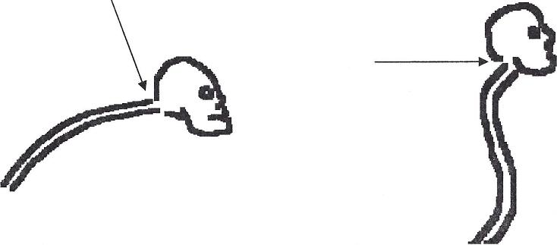

B Hominids through time

1 Earliest, 6-7 mya in Africa

a Australopithecines

(1) Used stone tools

(2) Walked on 2 legs (no opposable toe)

(3) Flatter forehead (larger brain)

(4) Humanlike jaws and teeth and feet

(5)"Lucy" 3.2 mya (Australopithecus afarensis)

b Global hominids

(1) Homo habilis — 2 mya

(2) Homo erectus — 1 mya — 300,000

(3) Homo Neanderthal — 400,000- 30,000

(4) Homo Sapien (wise man)

(i) Art

(ii) Religion

(iii) Extensive tools