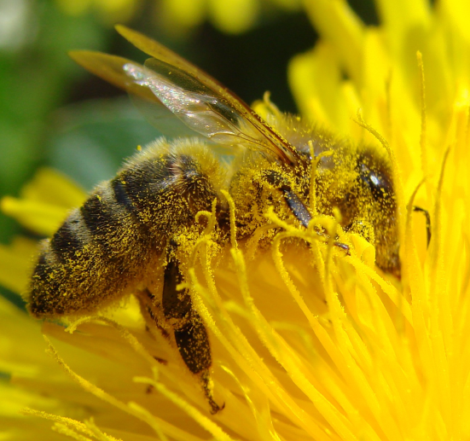
Flowers attract bees with their bright colors and smells. When the bee arrives it eats the pollen (a yellow protein) and sometimes nectar (a sugary liquid). While eating, pollen sticks to its legs and it then carries this pollen to other flowers. When pollen touches the pistil of a flower, it is called pollination. After pollination, flowers can reproduce by making seeds. The bee gets the benefit of food, and the flower gets the benefit of sexual reproduction.

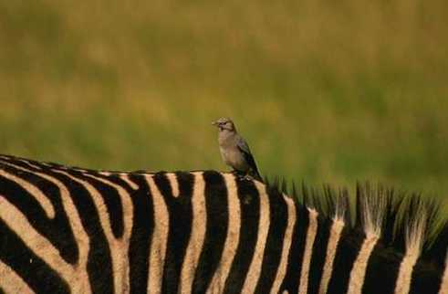
Oxpeckers (a type of bird), land on rhinos or zebras and eat ticks and other parasites that live on their skin. The oxpeckers get food and the beasts get pest control. Also, when there is danger, the oxpeckers fly upward and scream a warning.

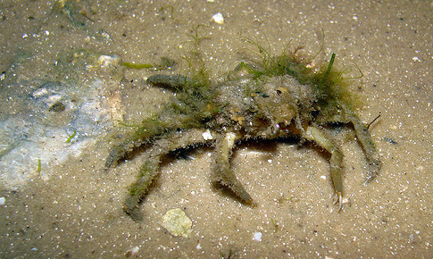
The spider crab and the algae. Spider crabs live in shallow areas of the ocean floor, and greenish-brown algae lives on the crabs' backs, making the crabs blend in with their environment, and unnoticeable to predators. The algae get a good place to live, and the crab gets camouflage.

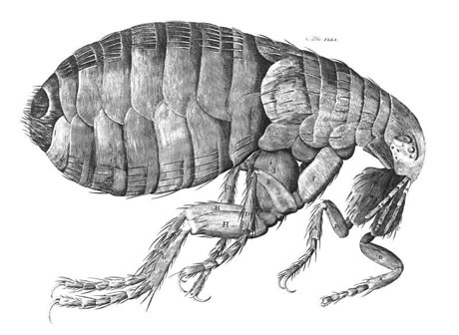
Fleas harm the harm the organism they live on. When on a dog, for example, they bite their skin, suck their blood, and cause them to itch. The fleas get food and a warm home, and the dog gets misery.

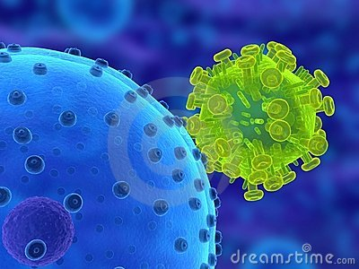
Viruses are nature’s hijackers. They latch onto cells, then insert DNA (instructions) into the cell forcing it to reproduce more viruses. A virus can only do its business if it comes in contact with living cells. The cold virus lodges itself in our noses and nasal passages. It gets to enjoy a warm, moist environment—perfect for its reproduction. The human (the host) enjoys no benefit (good thing) whatsoever.

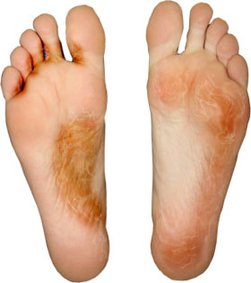
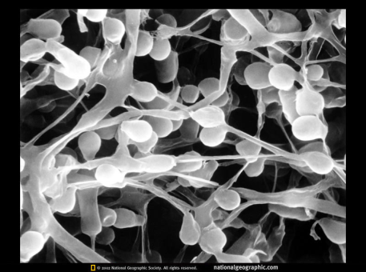
Athlete’s foot fungus up close
Normally fungi latch on to organisms after they are dead. We call them decomposers. But sometimes fungi attack LIVING organisms. There is a fungus causes wheat rust (a disease that attacks and kills wheat) and there is a similar downy mildew fungus that attacks fruit and vegetables. The fungus gets a food source, and the plants get to die. There is also a fungus that lives on human feet—athlete’s foot is what we call it. The fungus gets a source of food and the human gets sore itchy feet.
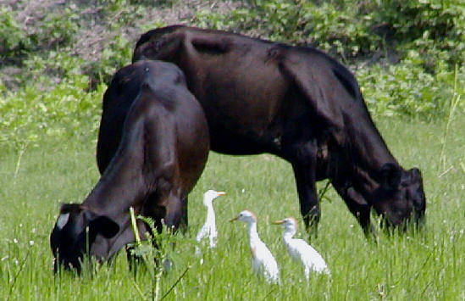
As cattle, horses and other livestock graze on the field, they cause movements that stir up various insects. As the insects are stirred up, the cattle egrets following the livestock catch and feed upon them. The egrets benefit from this relationship because the livestock have helped them find their meals, while the livestock are typically unaffected by the egrets.

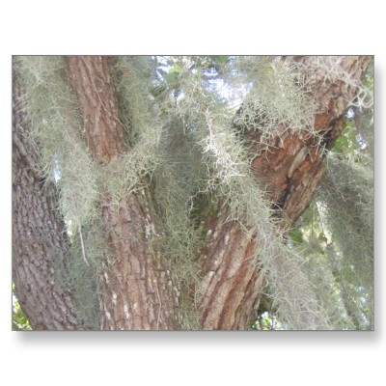

Orchids and mosses are plants that can have an interesting relationship with trees. The plants grow on the trunks or branches of trees. They get the light they need as well as nutrients that run down along the tree. As long as these plants do not grow too heavy, the tree is not affected.

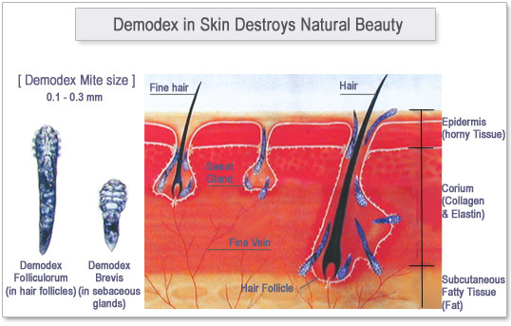
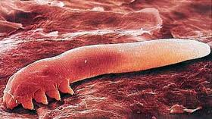

Demodex folliculorum is the scientific name for a type of mite that lives in human eyelash follicles. While they benefit by eating the oils in your skin, you are unaffected and don’t even realize they are there.

