**Wave review for final exam KEY**

***Define***

1. **WAVE-- A REPEATED DISTURBANCE THAT CARRIES ENERGY FROM ONE LOCATION TO ANOTHER**
2. **FREQUENCY-- HOW MANY WAVES PASS A SINGLE POINT IN ONE SECOND (MUSICIANS CALL IT PITCH)**
3. **WAVELENGTH-- HOW LONG A SINGLE WAVE IS FROM START TO FINISH AMPLITUDE--**
4. **VIBRATION-- DISTURBANCE CAUSED BY MOLECULES WIGGLING**
5. Circle the higher frequency

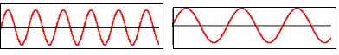

1. Circle the longer wavelength



1. Circle the higher amplitude



1. Give 3 examples of vibrations

**1 VOCAL CORDS**

**2 BELL RINGING**

**3 A HAND WAVING**

1. Label the nodes and antinodes

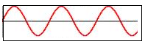

1. Which molecules are more energized, ones at the node or ones at the antinode?

**ANTINODES**

1. Label the crests and troughs **CREST = TOP ANTINODE TROUGH = BOTTOM ANITNODE**



1. What is the electromagnetic spectrum?

**CHART THAT SHOWS ALL 7 CATEGORIES OF ELECTROMAGNETIC WAVES**

1. What name the electromagnetic waves in order from lowest energy to highest energy

1 **RADIO**

**2 MICROWAVES**

**3 INFRARED**

**4 VISIBLE**

**5 ULTRVIOLET**

**6 XRAY**

**7 GAMMA**

1. Do electromagnetic waves need a medium?

**NO**

***What is the medium for….***

1. A tidal wave **WATER**
2. A sound wave **AIR**
3. A stadium wave **PEOPLE**
4. A seismic wave (earthquake) **THE EARTH (DIRT, ROCKS)**

***Waves behave in 6 different ways. If they***

1. Bend around a corner it’s called __**DIFFRACTION**____
2. Bend because they hit a different medium it’s called __**REFRACTION**____
3. Bounce off a surface it’s called ___**REFLECTION**__
4. Collide and add their amplitudes together it’s called __**CONSTRUCTIVE** **INTERFERENCE**___
5. Collide and cancel each other out it’s called ____**DESTRUCTIVE** **INTERFERENCE**___
6. Hit a medium and soak into it it’s called ___**ABSORPTION**____
7. Compressional (longitudinal) waves-

Wave moves sideways and the molecules move (up and down or back and forth)

1. Transverse waves-

Wave moves sideways and the molecules move (up and down or back and forth)

1. Label as either transverse or compressional (longitudinal)

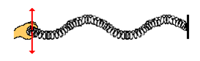

**COMPRESSIONAL** **TRANSVERSE**

1. Draw a wave that is at equilibrium
2. What is the main thing that a wave does?

**TRANSFERS** **ENERGY**

1. What is the proper order for the visible wavelengths from lowest energy to highest energy?

**RED, ORANGE, YELLOW, GREEN, BLUE, INDIGO, VIOLET**

1. IF coke is black and milk is white, which gets warmer quicker when sitting out in the sun?

**COKE**

1. What starts a wave?

**A DISTURBANCE OF THE MOLECULES OR A VIBRATION**

1. If the dotted line is the angle of incidence, which line is the angle of reflection?

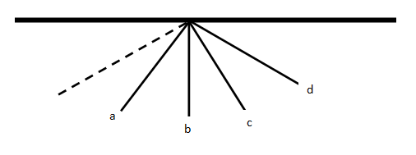

**ANGLE D**

1. Is the A substance reflective or absorptive?

**ABSORPTIVE**

1. Is the B substance reflective or absorptive?

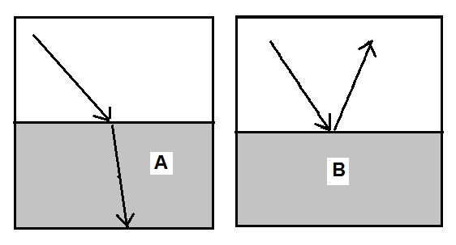**REFLECTIVE**

1. How does a seismic wave topple a building 20 miles from the focus?

**THE WAVES TRAVEL THROUGH THE EARTH TAKING THE MOTION ENERGY ALL THE WAY TO THE BUILDING**

