Alfred Wegener’s Hypothesis: The Earth’s land and oceans sit upon tectonic plates. These plates move around because they are floating on the soft and gooey asthenosphere. Therefore the continents as we see them today are not what they used to look like and are not what they are going to look like in the future.

PART 1:

You have put your continents together like a puzzle using the fossil evidence to guide you. This is what Alfred Wegener did. Have your teacher put initials here if you did it correctly. **(5pts)**

a

b

6) Now put your contents together like a puzzle using the fossil evidence to guide you. This is what Alfred Wegener did.

PART 2:

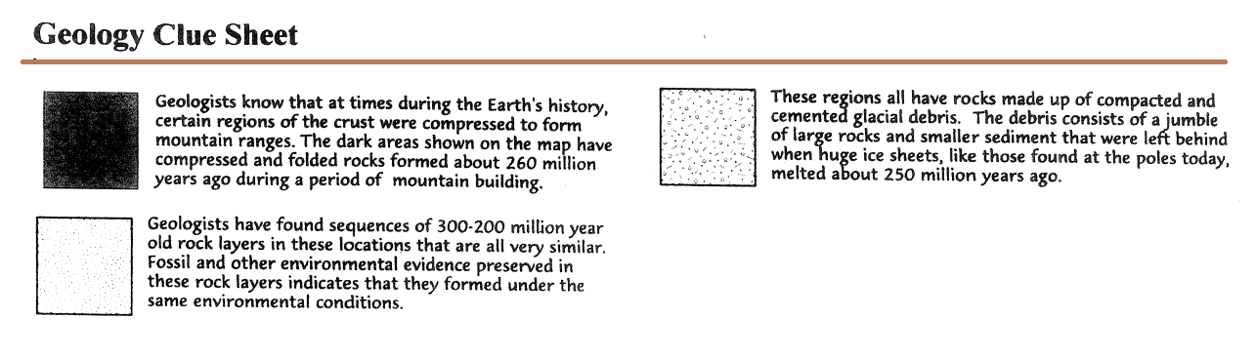

Now arrange the continents using the rock clues above in a similar way that you did with the fossil clues. This is what Alfred Wegener did. Have your teacher put initials here if you did it correctly. **(5pts)**

a

b

6) Now put your contents together like a puzzle using the fossil evidence to guide you. This is what Alfred Wegener did.

***ANSWER THE QUESTIONS BELOW***

1. Why did you cut out around the continents (where water is) and not the actual edge of the continent? **(1pt)**
2. Explain how the shape of the continents support Alfred Wegener's hypothesis **(1pt)**
3. Explain how fossils support Alfred Wegener's hypothesis **(1pt)**
4. Explain how the rock types and mountain ranges support Alfred Wegener's hypothesis **(1pt)**
5. Why is finding the Cynognathus fossil in Africa and South America AND the Lystosaurus fossil in Africa, Antarctica, and India almost impossible if Wegener is wrong? (hint: what can’t these animals do?) **(1pt)**
6. Why is finding the Glossopteris fossil in Antarctica strange? **(1pt)**
7. Why is finding evidence of glaciers in India strange? **(1pt)**
8. What evidence suggests that all the continents were once joined? **(3pts)**