NEWTON’S FIRST LAW NAME________________________HR_____

Activity One- The Air Force Marble Game

Materials
-Drinking straws
-Marble
-Notebooks

Procedure
- Have one person sit on one side of the table (the long side) while the other sits on the other side facing the first person.
- Set up the notebooks and books on the table so that there is a path about thirty centimeters wide that leads from you to your partner.
- Place the marble so that it is at the center of the table.
- On the count of three, each student tries to blow air through the straw in order to move the marble. The objective is to move the marble all the way across the table over your partner’s edge. You can only use air to move and stop the marble—no touching of any kind allowed. Keep track of your score.

What is Newton’s first law?
__________________________________________________________________________________________

__________________________________________________________________________________________

Explain in terms of Newton’s First Law of Motion why it was hard to get the marble rolling using only air and the straw.

__________________________________________________________________________________________

__________________________________________________________________________________________

__________________________________________________________________________________________

Explain in terms of Newton’s First Law of Motion why the marble was hard to stop once it got rolling using only air and the straw.

__________________________________________________________________________________________

__________________________________________________________________________________________

__________________________________________________________________________________________

Activity #2: Inertia – Golf Bombs
In this experiment you will try to drop a tennis ball on a target as you run past the target. Think it’s easy? Before you begin, try to guess what will happen. Try to figure out when you will need to release the ball in order to hit the target. Write down your predictions below, and be sure to explain the reasons why you think you are correct.
As you conduct this experiment, think of the challenges Air Force pilots had before the invention of the guided missiles that are used today. Pilots in World War II had to understand mathematics in order to drop bombs on targets while causing as little harm as possible to surrounding buildings and people. These are the same concepts that you will learn with this experiment.

MATERIALS: • one golf /tennis ball • target like a bulls-eye that is lightly taped to the floor
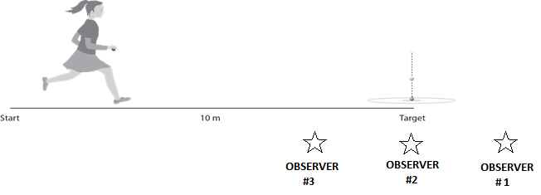
PROCEDURE:

1. Hold the tennis ball and do not let your elbow leave your side as you run and drop the ball. Do not throw the ball. You should hold the ball from its sides so that you can release your grip as you let it drop. Remember to drop the ball and not throw it, otherwise you will change the intent of the experiment.
2. Have three students stand alongside (but slightly back from) the running path to act as observers. One should stand just after the target #1, one at the target #2, and one before the target #3. Their objective is to determine exactly where the runner released the ball and where the ball strikes the ground.
3. Ask the runner to move toward the target as fast as she or he can and try to drop the ball so that it lands on the target. After running, you become observer #1. On the next trial, you are observer #2. On the next trial, you are observer #3. After being observer #3, you now go stand in line to make another run. Every student makes 2 attempts to hit the target.

1] Make a diagram of where the ball was released and where it landed

2] What would happen if a student ran at a slower speed? Sketch what it would look like

3] What does this activity have to do with Newton’s 1st law?

Activity #3: Knock My Block Off! NAME_____________HR___
SCIENTIFIC QUESTION: How does mass affect an object’s inertia?

HYPOTHESIS: I think ________________________________________________________________

__________________________________________________________________________________________

Using the picture below as a guide, design an experiment to test your hypothesis. Write the steps below:

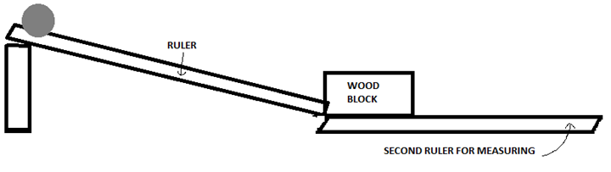

1_________________________________________________________________________________________

2_________________________________________________________________________________________

3_________________________________________________________________________________________

4_________________________________________________________________________________________

5_________________________________________________________________________________________

DATA: Create a table below that neatly organizes the numbers you collect in this experiment

- What was the independent variable in this experiment?

- What was the dependent variable in this experiment?

- Name at least 3 controlled variables in this experiment.
1
2
3

ARGUMENT WITH EVIDENCE: (2POINTS)

- How does mass affect an object’s inertia? Be sure to use data from your experiment to prove your claim.

_________________________________________________________________________________________

_________________________________________________________________________________________

_________________________________________________________________________________________

- How will the voyager spacecraft still travel 38,000 miles per hour even after it runs out of fuel?

_________________________________________________________________________________________

_________________________________________________________________________________________

- Why don’t moving objects on Earth continue on forever and ever?

_________________________________________________________________________________________

_________________________________________________________________________________________

- Why is it really easy to start making a snowman, but after a while it gets really hard? Explain using Newton’s first law of motion

_________________________________________________________________________________________

_________________________________________________________________________________________

