LIFE IN THE OCEANS ONLINE ASSIGNMENT /57 NAME ___________________________ HR___
Do a google search to find out what the different ocean environments are. Label the picture below. Be sure to label the bathypelagic zone, the mesopelagic zone, the epipelagic zone, the hadal zone, and the abyssopelagic zone. (5 points)
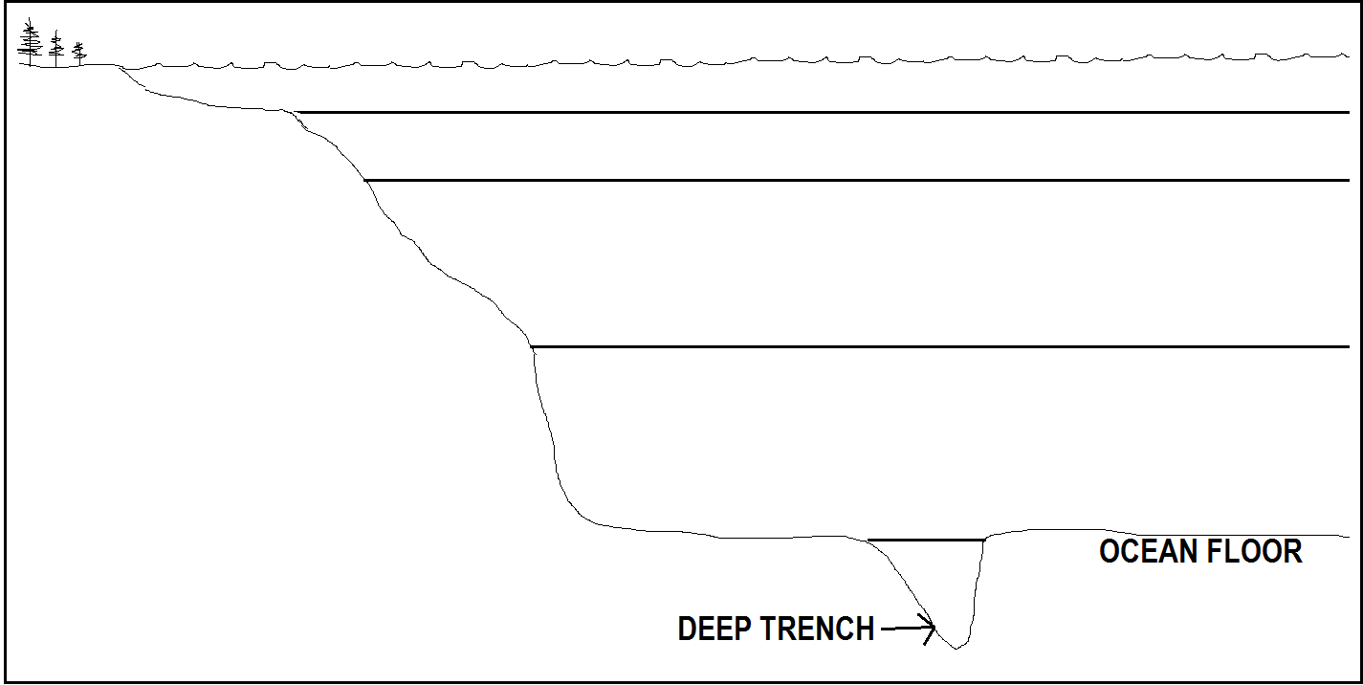
FILL IN THE CHART BELOW: (25 pts)
OCEANIC ZONE NAME | CREATURES FOUND HERE? (NAME AT LEAST 3) | DISTANCE DOWN? | SUNLIGHT PENETRATES?  Yes or no?
Epipelagic
Mesopelagic
Bathypelagic
Abyssopelagic
hadalpelagic

Go to the following movie link and answer the questions below. The questions follow the movie and are in order.
https://www.nationalgeographic.org/media/deep-sea-hydrothermal-vents/
- What is the name of the submersible they used? __________________________
- What are the white tubes with red on top called? __________________________
- Does sunlight reach the bottom of the ocean? __________________________
- The chemicals by the plumes are ___________________ to humans
- The process of converting chemicals to energy is known as __________________
- What are the structures called that they found? __________________________
- First the water seeps down into cracks and gets superheated by _______________.
- What does it pick up as it boils up and rises? __________________________________________________
- What is the name of a hydrothermal vent that emits water like a thick black cloud? ________________________
- The hydrothermal vents that contain barium, calcium and silicon are called? __________________________
CONTINUED ON BACK SIDE-
- Some hydrothermal vents give off bubbles of ___________________________.
- The water pressure is very ___________________ at the bottom of the ocean
- The temperature can get up to ___________________ Fahrenheit
- Why doesn’t it boil? _______________________________________________________________
Read questions 15-22 first. Watch the videos. The questions are NOT in order, but should be easy to answer AFTER watching the videos
https://www.youtube.com/watch?v=ER2KsU2I4_Y
https://www.youtube.com/watch?v=gT5_z3CKXBo
- Does sunlight reach here? __________________________
- What is the bottom of the food chain in the bottom of the ocean? __________________________
- How do bacteria make food for themselves if there is no sunlight energy to help them? ______________________
- What raw materials do bacteria use to make sugar? _________________________________________________
- What role do tubeworms play in the ecosystem at a hydrothermal vent? __________________________
- What niche does the bacteria have in this ecosystem? (consumer, producer, herbivore, carnivore, omnivore, decomposer?) __________________________
- Name at least one consumer in this ecosystem. __________________________
- Draw a food chain of at least 3 organisms to show how energy flows in this ecosystem (1pt)

Using google, research “deep sea creatures” or “hydrothermal vents” or “benthic organisms” to find an organism that interests you. Briefly sketch below and fill in the details about the organism. Make sure that the organism is not extinct and that the organism actually exists. Some people are great at photoshop. If you are not sure, just ask me.

- What is the name of your creature?

- How far down does it live?

- How does your creature get energy?

- What niche does this creature have in the ecosystem?

- What special traits or adaptations does this creature have?

