Newton's Third Law
A force is a push or a pull that acts upon an object as a results of its interaction with another object. Forces result from interactions! Some forces result from contact interactions (normal, frictional, and tensional forces are examples of contact forces) and other forces are the result of action-at-a-distance interactions (gravitational, electrical, and magnetic forces). According to Newton, whenever objects A and B interact with each other, they exert forces upon each other. When you sit in your chair, your body exerts a downward force on the chair and the chair exerts an upward force on your body. There are two forces resulting from this interaction - a force on the chair and a force on your body. These two forces are called action and reaction forces and are the subject of Newton's third law of motion. Formally stated, Newton's third law is:
For every action, there is an equal and opposite reaction.
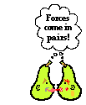
The statement means that in every interaction, there is a pair of forces acting on the two interacting objects. The size of the forces on the first object equals the size of the force on the second object. The direction of the force on the first object is opposite to the direction of the force on the second object. Forces always come in pairs - equal and opposite action-reaction force pairs.
Examples of Interaction Force Pairs
A variety of action-reaction force pairs are evident in nature. Consider the propulsion of a fish through the water. A fish uses its fins to push water backwards. But a push on the water will only serve to accelerate the water. Since forces result from mutual interactions, the water must also be pushing the fish forwards, propelling the fish through the water. The size of the force on the water equals the size of the force on the fish; the direction of the force on the water (backwards) is opposite the direction of the force on the fish (forwards). For every action, there is an equal (in size) and opposite (in direction) reaction force. Action-reaction force pairs make it possible for fish to swim.
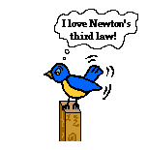
Consider the flying motion of birds. A bird flies by use of its wings. The wings of a bird push air downwards. Since forces result from mutual interactions, the air must also be pushing the bird upwards. The size of the force on the air equals the size of the force on the bird; the direction of the force on the air (downwards) is opposite the direction of the force on the bird (upwards). For every action, there is an equal (in size) and opposite (in direction) reaction. Action-reaction force pairs make it possible for birds to fly.
Consider the motion of a car on the way to school. A car is equipped with wheels that spin. As the wheels spin, they grip the road and push the road backwards. Since forces result from mutual interactions, the road must also be pushing the wheels forward. The size of the force on the road equals the size of the force on the wheels (or car); the direction of the force on the road (backwards) is opposite the direction of the force on the wheels (forwards). For every action, there is an equal (in size) and opposite (in direction) reaction. Action-reaction force pairs make it possible for cars to move along a roadway surface.

You probably know that the Earth pulls down on you. What you might not realize is that you are also pulling up on the Earth. For example, if the Earth is pulling down on you with a gravitational force of 500 N, you are also pulling up on the Earth with a gravitational force of 500N. The pulling power of your body’s gravity is tiny though, and it is trying to exert its force on the massive Earth. For this reason, the Earth is hardly affected at all by the tiny amount of gravity your body has. However, even though the Earth’s gravity on you is the exact same amount of force (500N), your body is greatly affected by it. So, even though the forces are equal, they are acting on different objects so the outcome is not the same.

One might think that if these opposite forces are equal, then no motion should occur. This is not true; equal and opposite forces often DO create motion. Consider the example of a swimmer.
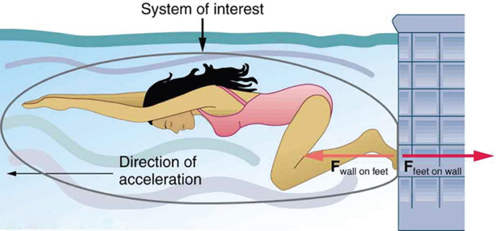
Notice how the vector arrows are exactly the same size. The action force (her feet pushing on the wall) creates a reaction force (the wall pushing on her feet). Her foot force might be 650 Newtons, but that force is just not strong enough to do anything significant to the wall like crack it or break it. The wall pushes on her feet with 650 Newtons as well, but this force IS strong enough to actually move the girl. So, because these equal forces are acting on different objects, one of the objects might actually move because it has less mass.

