8th Grade Notes 21-1 /41 Name ______________ hr__
OCEAN CURRENTS

I. Ocean currents = a horizontal _______________ of water in a well-defined _____________
A. _______________ CURRENTS = a horizontal _______________ of ocean water at or near the surface of the ocean.
1. Three factors that control surface currents
a) _______________ CURRENTS (aka _______________)
- As air in areas of low pressure _______________ and air in areas of high pressure _______________, wind is created.
- Air always moves from _______________ pressure towards _______________ pressure.
- The wind’s _______________ energy is transferred to the ocean surface water as the air flows over it.

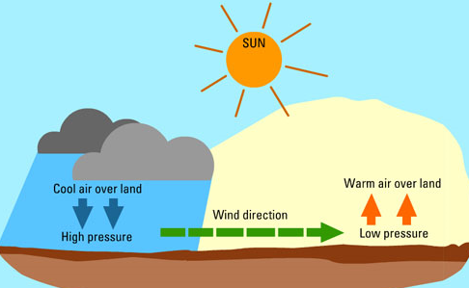

b) EARTH’S _______________ (_______________ EFFECT) = the _______________ path wind or water takes due to Earth’s rotation. The Coriolis effect forms the _______________ winds that drive ocean surface currents.
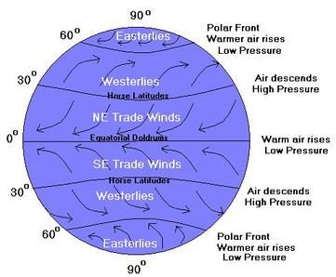
c) Location of _______________

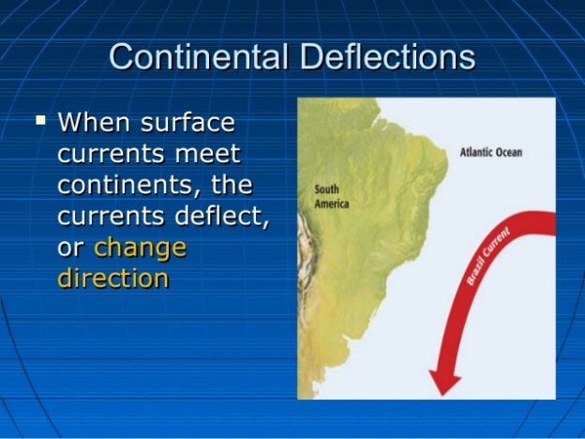

2. Major _______________ currents
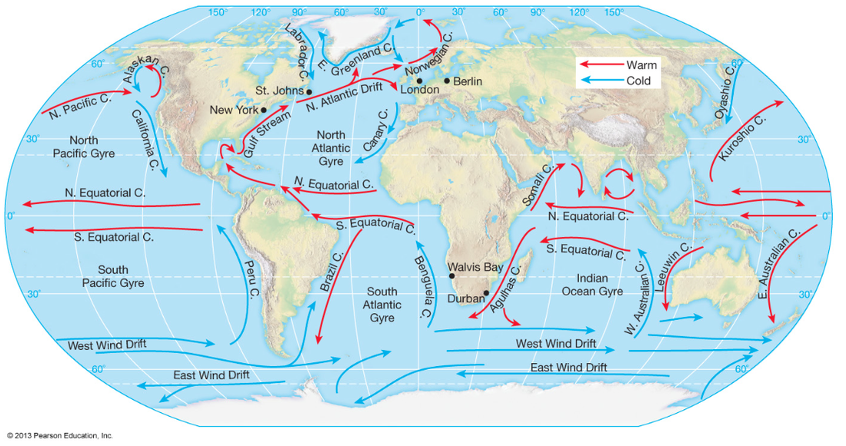
B) _______________ currents = a stream-like movement of ocean water far below the surface.
1. Three factors that control deep currents
a) _______________
- cold, _____________ polar water sinks and flows ______________
- ___________, less dense equatorial water rises and flows __________
- in general, cold deep water from the _______________ flows toward the _______________, and
- warm shallow water from the _______________ flows toward the _______________
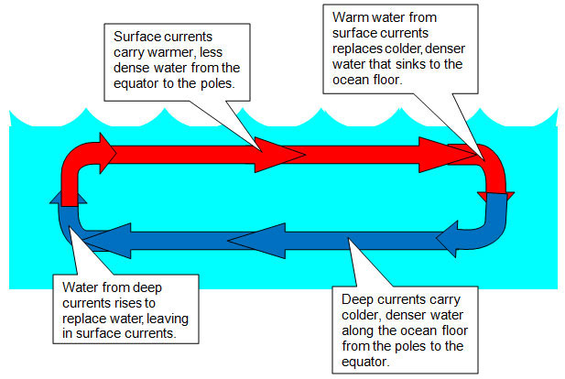
b) wind at _______________ - surface winds can create an _______________ – a deep current that flows up to the surface along a coastline. How it works:
- when wind blows along a _______________, it pushes water 90 degrees in the other _______________.
- The water moves away from the _______________ and out to sea.
- Deep, _______________ water from below rises up to take its _______________.
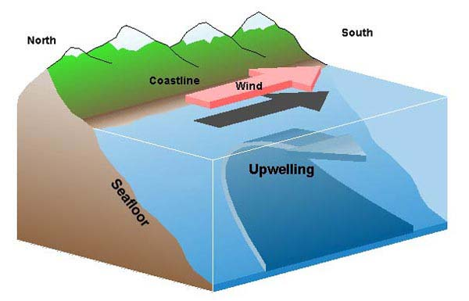
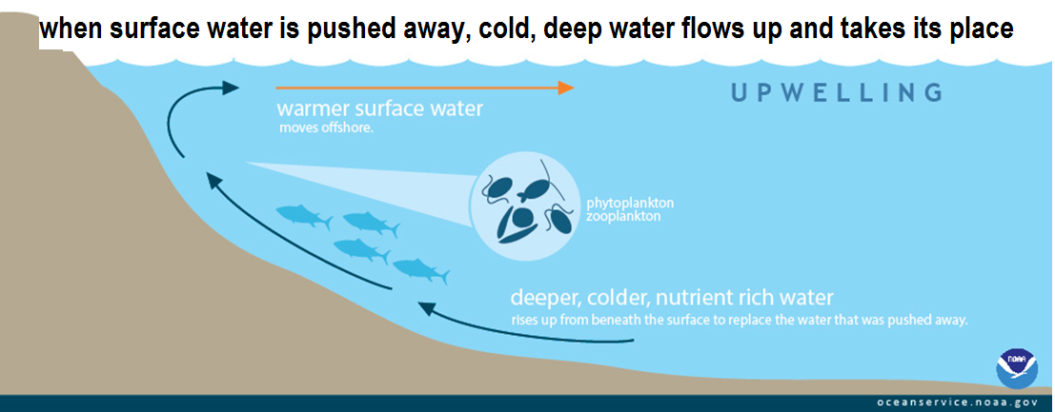

c) _______________ – how salty the water is
    - water that is more saline _______________ because it is more _______________
    - water that is less _______________ stays on top because it is _______________ dense

C) _____________ current = a strong current caused by an underwater ______________
