If global warming continues, ocean water temperature will increase. If the ocean water temperature increases, dissolved oxygen levels will decrease. Plankton is the basis for the ocean food chain. There are 2 types: phytoplankton which make their food by photosynthesis (plant like) and zooplankton which get their food by consuming (animal like).

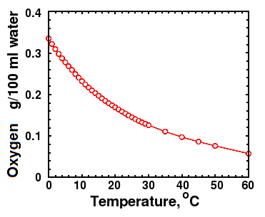

- How will this oxygen decrease affect different ocean populations?

Ocean acidification is a term used to describe the changes in the chemistry of the world's seas, primarily as a result of burning fossil fuels. As carbon dioxide (a greenhouse gas produced by humans burning fossil fuels) increases in the atmosphere, more of it dissolves into the ocean. Study the graphic to see what happens next.

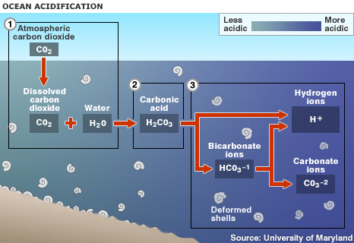

1. Up to one half of the carbon dioxide (CO2) released by burning fossil fuels over the past 200 years has been absorbed by the world's oceans

2. Absorbed CO2 in seawater (H2O) forms carbonic acid (H2CO3), lowering the water's pH level and making it more acidic

3. This raises the hydrogen ion concentration in the water, and limits organisms' access to carbonate ions, which are needed to form hard parts

- What is the major problem caused by acidification?

Scientists have collected data for the amount of carbon dioxide in the atmosphere. Since the 60’s they got the data from the atmosphere. For the previous years they collected CO2 from trapped atmosphere found in ice cores.
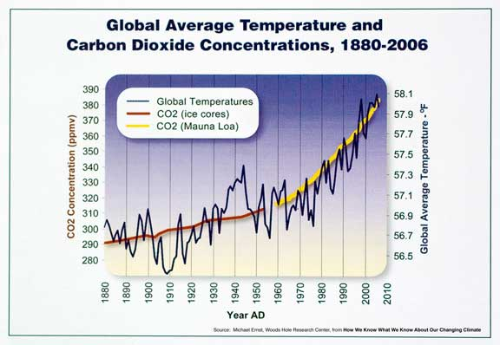

- Is the global temperature related to carbon dioxide levels? How?

We're Headed for Vast Ocean Extinction
Human activity has degraded the world's oceans with dizzying speed and a mass extinction of marine life only seen five times before in the planet's history is likely if urgent action is not taken, a panel of marine experts warns. The International Program on the State of the Oceans panel, made of experts from a variety of disciplines, found that issues such as climate change, overfishing, acidification, and pollution are acting together to accelerate the rate of change, reports the BBC.
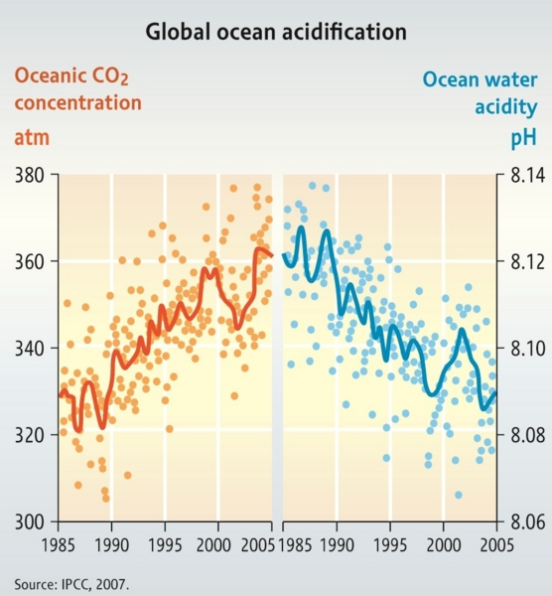
The panel found that conditions in the ocean are starting to resemble those associated with mass extinctions in the past. They warn that entire ecosystems like coral reefs could disappear within a single human generation. "The findings are shocking," IPSO's scientific director said in a statement. "This is a very serious situation demanding unequivocal action at every level. We are looking at consequences for humankind that will impact in our lifetime, and worse, our children's and generations beyond that."

Marine scientists are concerned that changes to the
oceans' pH levels will have severe consequences for
marine wildlife and ecosystems.

- What are the reasons given for why there may be massive ocean extinctions in our future?

Preliminary figures for glacier mass balance for 2010/2011 have just been released and show that data from more than 100 mountain glaciers from around the world continue a strong trend of losing mass. The melt water from glaciers flows into the oceans and adds to sea level rise.
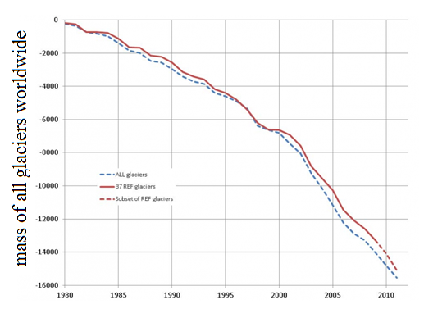
800_20130117_glaciers_fig...
original image ( 976x695)
The report says:
"The average mass balance of the glaciers with available long-term observation series around the world continues to be negative, with tentative figures indicating a further thickness reduction of one metre water equivalent (m w.e.) during the hydrological year 2011. The new data continues the global trend in strong ice loss over the past few decades and brings the cumulative average thickness loss of the reference glaciers since 1980 at more than 15 m w.e."
I reported in January 2011 on research from Canada that most mountain glaciers are on the retreat. Many glaciers in Europe, New Zealand, Africa and the US Rocky Mountains will lose up to 75 per cent of their mass by the end of the century. The melt from mountain glaciers will contribute up to 12 centimetres of sea level rise by 2100.
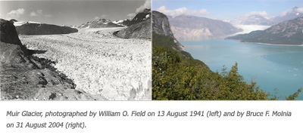

- What is the graph showing? Why is this happening?
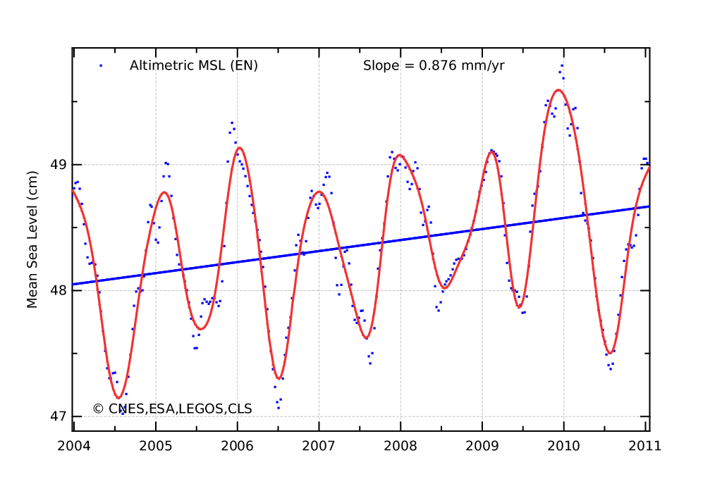

FLOOD RISK DATA

Historically, cities have been located on coastlines because there are many transport, food and ecological benefits. In the United States, counties directly on the shoreline constitute less than 10 percent of the total land area (not including Alaska), but account for 39 percent of the total population. Coastal areas are substantially more crowded than the U.S. as a whole, and population density in coastal areas will continue to increase in the future. In fact, the population density of coastal shoreline counties is over six times greater than the corresponding inland counties. By 2020 47% of all people in the US will live on the coast. Where will they move to when the ocean takes over their homes?

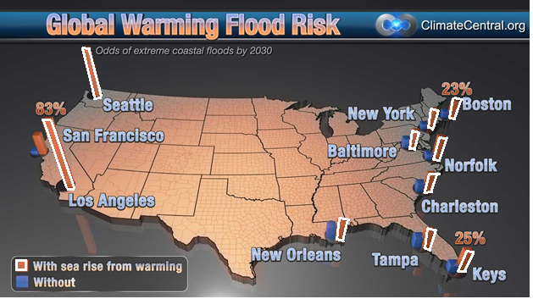

- How is the sea level changing? How will this impact people in the USA? How will this impact people globally?
ECONOMIC IMPACT OF GLOBAL WARMING (JUST 1 YEAR)

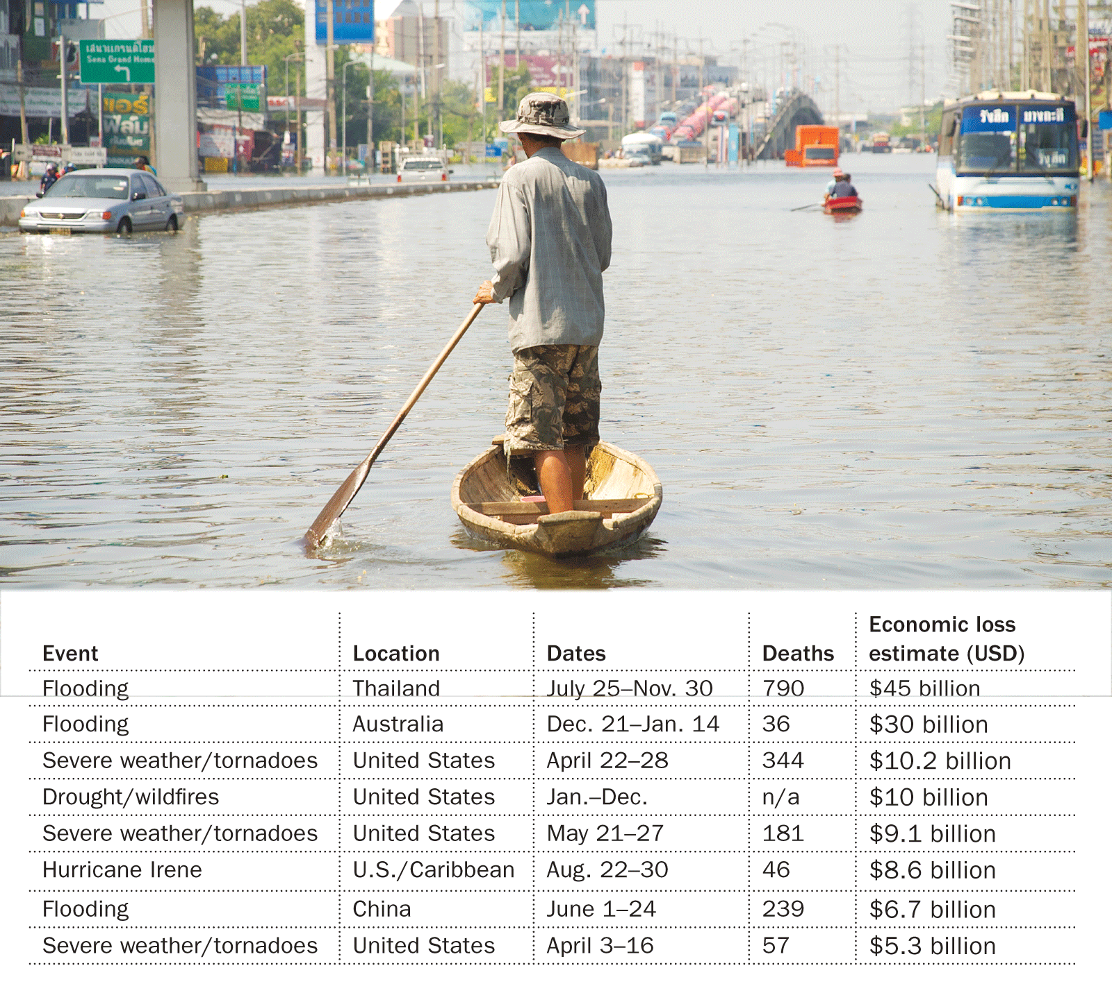

- Why does flooding cause an economic impact?
Why does drought cause an economic impact?
Why do fires cause an economic impact?
Why do tornadoes cause an economic impact?
Why do hurricanes cause an economic impact?

DROUGHT DUE TO GLOBAL WARMING
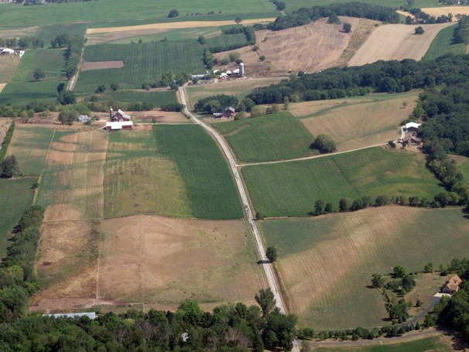
View Photo Gallery — The drought of 2012: It has been more than a half-century since a drought this extensive hit the United States, NOAA reported July 16. The effects are growing and may cost the U.S. economy $50 billion.
The United States will suffer a series of severe droughts in the next two decades, according to a new study published in the journal Nature Climate Change. Moreover, global warming will play an increasingly important role in their abundance and severity, claims Aiguo Dai, the study’s author.
While the variations in sea temperatures primarily influence precipitation, global warming is expected to bring droughts by increasing evaporation over land. Additionally, Dai predicts more dryness in South America, Southern Europe and Africa.

- HOW DOES GLOBAL WARMING INCREASE DROUGHT?

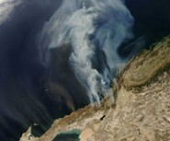
Fire Influences Global Warming More Than Previously Thought

These are smoke plumes from southern California wildfires billowing out over the Pacific ocean.
Fire's potent and pervasive effects on ecosystems and on many Earth processes, including climate change, have been underestimated, according to a new report.
"We've estimated that deforestation due to burning by humans is contributing about one-fifth of the human-caused greenhouse effect -- and that percentage could become larger," said co-author Thomas W. Swetnam of The University of Arizona in Tucson.
"It's very clear that fire is a primary catalyst of global climate change," said Swetnam, director of UA's Laboratory of Tree-Ring Research.
The team also reports that all fires combined release an amount of carbon dioxide into the atmosphere equal to 50 percent of that coming from the combustion of fossil fuels.
"Fires are obviously one of the major responses to climate change, but fires are not only a response -- they feed back to warming, which feeds more fires," Swetnam said.
When vegetation burns, the resulting release of stored carbon increases global warming. The more fires, the more carbon dioxide released, the more warming -- and the more warming, the more fires. This is called a positive feedback loop.
- WHY DOES GLOBAL WARMING CREATE MORE FIRES?
HOW DO MORE FIRES MAKE MORE GLOBAL WARMING?

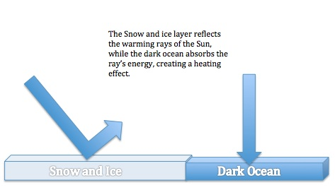
Ice-albedo feedback
Ice has a higher albedo (or reflectivity) than vegetation, soil, or water. As ice expands, more solar radiation is reflected to space, less is absorbed by the surface, and temperatures decrease. Cooler temperatures lead to more ice growth, more reflection of solar radiation back to space, and even cooler temperatures - a positive feedback. But positive ice-albedo feedbacks can work in the opposite direction as well. Once ice begins to melt and uncover land or water, more solar radiation will be absorbed by the surface, raising temperatures and causing even more ice to melt. This positive feedback might act more quickly over the oceans than over land because sea ice can melt faster than large continental ice sheets.
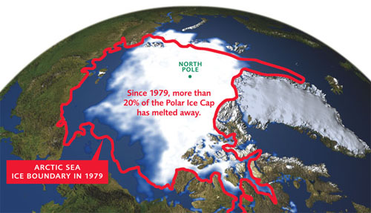

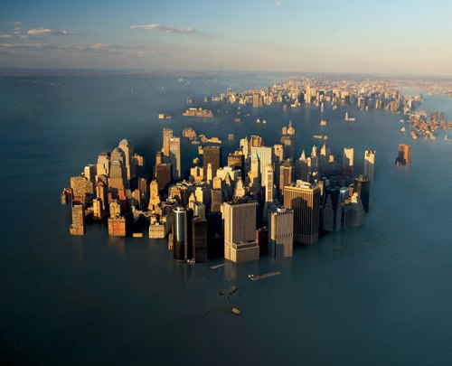

- WHY IS THE LOSS OF ICE AT THE POLES MAKING GLOBAL WARMING EVEN WORSE?

- IS THIS OUR FUTURE? WHAT CHANGES CAN WE MAKE TO PREVENT (OR REDUCE) THIS?
