NOTES: TIDES CHAPTER 21-3 NAME _____________________Hr__
- TIDE DEFINITION- the periodic _______________ and _______________ of the water level in oceans
  - _______________ tide- when water level is lowest
  - _______________ tide- when water level is highest
- Causes of tides
  - Moon’s _______________ pull- it is more than _______________ as powerful as the sun’s gravitational pull because the moon is much _______________ to the earth
  - _______________ gravitational pull- less powerful – even though the sun is _______________, it is so _______________ away it has _______________ influence than the moon
- Why is there a _______________ on the side _______________ facing the moon?
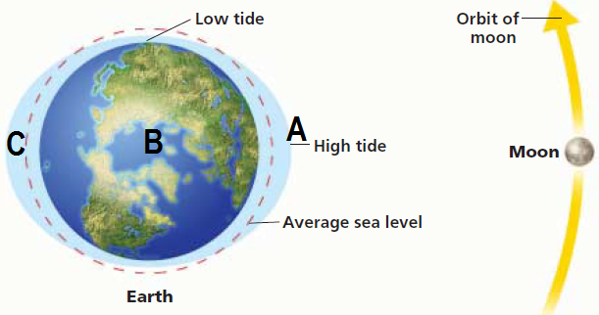
  - At point a, there is an obvious _______________ bulge because of the moon’s gravity.
  - At point b, the moon is pulling on Earth as well, but _______________ as hard as at point A, because it’s _______________ away
  - At point c, the moon has the _______________ influence. This water is not _______________ on as much, so it gets “_______________ _______________”
- Types of tides
  - _______________ tide – the sun, moon, and earth are all _______________ up and thus the sun’s gravity _______________ to the pull of the moon
    - The high tide is _______________
    - The low tide is _______________
    - Happens during _______________ moon and _______________ moon
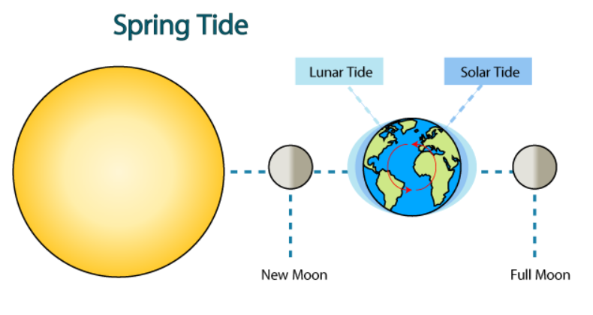
  - _______________ TIDE – the sun and moon are _______________ degrees apart relative to the earth, causing _______________ extreme tidal changes
    - High tide is _______________
    - Low tides are _______________
    - Happens during _______________ quarter and _______________ quarter
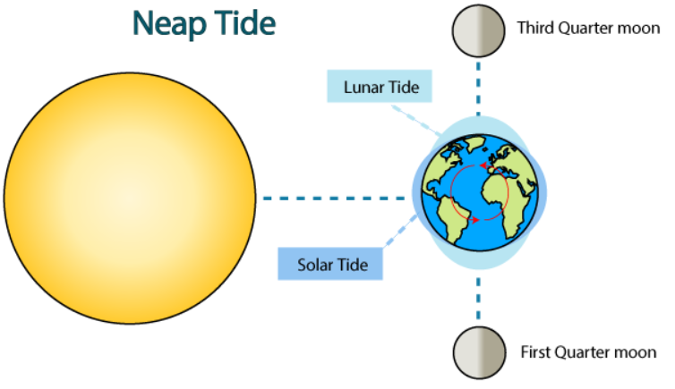

- Tidal _______________
  - _______________ tide- tide current flows _______________ the coast
  - _______________ tide- tide current flows back out to the _______________
  - _______________ _______________ - time between flood and ebb tide where there are _______________ tidal currents
  - Tidal _______________ – surge of water that rushes _______________ in a river
- Tidal patterns – tides are _______________ the same everywhere because bodies of water are different _______________, _______________, and _______________.
  - _______________ – 1 high tide and 1 low tide each _______________
  - _______________ _______________ – 2 high tides and 2 low tides each day (both about the _______________ height each time)
  - _______________ _______________ _______________ - 2 high tides and 2 low tides each day (_______________ heights each time)

