REVIEW – THE OCEAN /135 NAME _____________________Hr__

OCEAN WATER PROPERTIES CHAPTER 20-1

- What types of things can be dissolved in ocean water?
1
2

- How do gases get dissolved in ocean water (4 pts)
1
2
3
4
- How does temperature affect how much gas can dissolve in water?

- Why is ocean water considered a CARBON SINK?

- What brings dissolved solids in to the ocean?

- What are the sources of the dissolved solids?
1
2
3

- What word do we use to describe the amount of dissolved solids in water?

- Which has a greater salinity, fresh or ocean water? What are the percentages? (3pts)
1
2
3

- What 2 processes can increase the salinity of water? Explain each (4pts)
Process | How it works:

- Describe the 3 temperature layers of the ocean (6pts)
Name of layer | What it is like

- How does cold water affect its density? Warm? (2 pts)
1
2

OCEAN CURRENTS CHAPTER 21-1

- Define Ocean current –

- What are the 2 kinds of ocean currents?
1
2
- What 3things cause the surface currents?
1
2
3
- In general, low pressure air _______________ and high pressure air ______________

- Wind always moves from ______________ pressure to ______________ pressure areas

- Why doesn’t the wind flow in straight lines from the north pole to the equator?

Describe what the air is doing
- Polar easterlies, northern hemisphere
- Westerlies, northern hemisphere
- Horse latitudes, northern hemisphere
- Trade winds, northern hemisphere
- Equatorial doldrums

- Trade winds, southern hemisphere
- Horse latitudes, southern hemisphere
- Westerlies, southern hemisphere
- Polar Easterlies, southern hemisphere

- What makes an ocean current deflect?

- How does a northern hemisphere gyre move?

- How does a southern hemisphere gyre move?

- In general, ocean currents at the equator move what direction and are what temperature?

- The California and canary currents are moving south (and one would think be getting warmer), and yet they become cold currents. Why?

- What causes an upwelling?

- How does the water current flow in an upwelling?

- What factors control the DEEP currents of the ocean? How does it affect the current? (6pts)
Factors | How is affects the ocean current

- What is a turbidity current? Explain.

TIDES CHAPTER 21-3

- Define tide:

- What 2 things cause tides?
1
2

- Why is the moon a more powerful influence on tides than the sun?

- Why is there a bulge on the side NOT facing the moon?

- What are the 2 types of tides?
1
2
- Describe the position of the moon and sun relative to earth during spring tide

- What lunar phases occur during spring tide?
1
2
- What are the high tide like at spring tide? Low tides? (2 pts)
1
2
- How would you describe the gravity forces at spring tide?

- Describe the position of the moon and sun relative to earth during neap tide

- What lunar phases occur during neap tide?
1
2
- What are the high tide like at neap tide? Low tides? (2 pts)
1
2
- How would you describe the gravity forces at neap tide?

- What is flood tide?

- What is ebb tide?

- What is slack water?

- What is a tidal bore?

- Which tidal pattern is shown by the graphs below? (3pts)

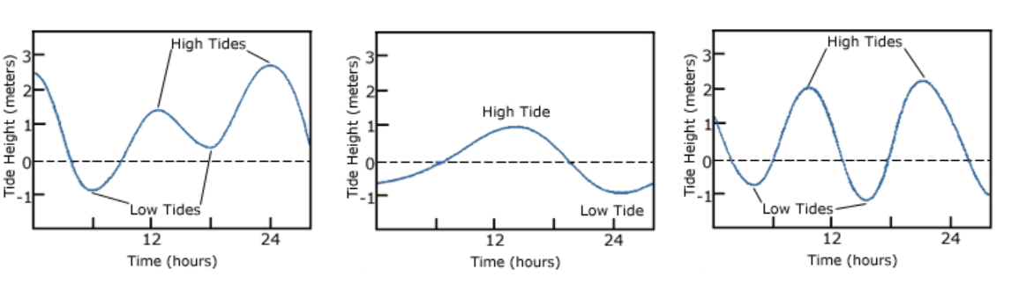
_________________________ _________________________ ________________________

OCEAN ECOLOGY AND ENERGY TRANSFER

- What is the name of the study of how organism interact with each other and the environment?

- What does biotic mean?

- What does abiotic mean?

- Define ecosystem

- Creatures that do either photosynthesis or chemosynthesis are both filling which niche in an ecosystem?

(10pts) | Who does it in the ocean? | Where in the ocean does it happen? | What is the energy source? | What is being produced? | In the light or darkness?
Photosynthesis
chemosynthesis

- What does it mean to be a producer?

- What is a consumer?

- Compare and contrast carnivore and consumer. (how are they alike, how are they different?)
1
2

- If you were to count all the calories in all of the vent octopuses and all the calories in the vent mussels at a hydrothermal vent, which would have more calories?

- Which would have the greater population?

- Which ocean zones are powered by the sun?
1
2
- Which ocean zones are powered by radioactive decay?
1
2
3

- The sunlight can penetrate which ocean zones?
1
2

- Which ocean zones have phytoplankton?

- Which ocean zones have zooplankton?

- What is the difference between zooplankton and phytoplankton?

- What is the base of the food chain at the surface of the ocean?

- What is the base of the food chain at the bottom of the ocean?

- What is chemosynthesis?

- Label the formulas below:
CO₂ + 6H₂O -> C₆H₁₂O₆ + 6O₂ =

CO2 + 4H₂S + O₂ -> CH₂0 + 4S + 3H₂O =

- Give an example of a mutually benficial relationship in the vent ecosystem

- Give an example of a parasitic relationship in the vent ecosystem

- What is commensalism?

- Draw a food chain for the hydrothermal vent ecosystem

- Draw a food web for the hydrothermal vent ecosystem (use 6 organisms)

- What organisms go at the bottom of an energy pyramid?

- Why is the bottom fatter?(give 2 reasons)
1
2

- What happens every time you move up a trophic level?

- Why does there have to be a greater population at the bottom of an energy pyramid?

