WHALE ANCESTRY: DNA Activity

NAME__________________ HR ___ /35 points

**SCIENTIFIC QUESTION**: Which 2 groups of mammals are whales *most* closely related to?

DNA to the rescue! As we learn the DNA sequences of more and more organisms, we can compare corresponding sequences to see which living species have DNA that is most alike. As the DNA for a particular gene is inherited by new descendent species, and time passes, mutations can occur (replacements of former DNA bases by different bases), many without any significant effect. The more time that has passed (the more distant the ancestry), the more mutations will have occurred, and the more differences we will find.

You will be provided with eleven DNA segments from the gene for beta-casein, a milk protein found in all mammals. The segment is 60 base pairs (bp) long, from bp 141 to bp 200 in the gene. That same corresponding segment is presented for 11 species, including 3 Cetaceans: Right Whale, Sperm Whale, and a Porpoise; 7 Artiodactyls: a Giraffe, a Hippo, a Cow, a Camel, a Deer, Domestic Pig, and a Peccary; and one Perissodactyl: the Indian Rhino. The Rhino serves as a basis for comparison as an “outgroup.”

**HYPOTHESIS** (1pt): I think

PROCEDURE:

1. Align the DNA segments from two species, and count the number of loci where the bases differ. For each pair of species compared, place the number of differences in the proper space on the grid below.

2. Each team (OF 3-4) will be assigned approximately 5 species to compare. As you count how many differences the milk gene has, you will write your data in the table below and on the whiteboard. Each team will collect the data that other teams provide until our chart is complete.

**THE NUMBER OF DIFFERENCE IN THE MILK GENES (4pts)**

|  |  |  |  |  |  |  |  |  |  |  |
| --- | --- | --- | --- | --- | --- | --- | --- | --- | --- | --- |
| S.Whale | 3 |  | | | | | | | | |
| Porpoise | 3 | 2 |  | | | | | | | |
| Giraffe | 10 | 9 | 9 |  | | | | | | |
| Hippo | 4 | 3 | 3 | 9 |  | | | | | |
| Cow | 9 | 8 | 8 | 3 | 8 |  | | | | |
| Camel | 12 | 11 | 11 | 15 | 12 | 14 |  | | | |
| Deer | 11 | 10 | 10 | 3 | 10 | 4 | 16 |  | | |
| Pig | 11 | 10 | 10 | 12 | 11 | 13 | 14 | 13 |  | |
| Peccary | 14 | 12 | 13 | 17 | 14 | 16 | 16 | 18 | 7 |  |
| Rhino | 13 | 12 | 12 | 16 | 13 | 15 | 11 | 16 | 15 | 15 |
|  | R.Whale | S.Whale | Porpoise | Giraffe | Hippo | Cow | Camel | Deer | Pig | Peccary |

WHALE DNA Analysis Questions NAME _____________________HR___

You will find that the numbers sort into two groups: Pairs with 2-4 differences, then pairs with 7-18 differences.

1. List the pairs of species with only 2-4 differences in their DNA (show number of differences for each pair)(8)

2 Porpoise - Sperm Whale

3 sperm whale / rt whale

3 porpoise / rt whale

3 sperm whale / hippo

3 porpoise / hippo

4 giraffe / cow

3. giraffe / deer

3 hippo / rt whale

4 deer / cow

2. Notice in the 9 pairings listed above that there are 4 species that are found in all 3 possible combinations with each other. What are those **4 species**? (Give common names, as used on the strips): (4pts)

SPERM WHALE / RT WHALE / PORPOISE / HIPPO

3. What does this suggest about how close those 4 species are related to each other (or how relatively recent they branched from a common ancestry?

CLOSELY RELATED / BRANCHED APART RECENTLY

4, Then there are 3 species that are found in their own 3 possible combinations. What are those **3 species**?

COW / DEER / GIRAFFE

5. What does this suggest about how close those 3 species are related to each other (or how relatively recent they branched from a common ancestry)?

CLOSELY RELATED / BRANCHED APART RECENTLY

6. Notice that there is a gap in the number of differences between pairs of DNA segments, showing none with 5-6 differences, and only one with 7 differences. **What two species** show 7 differences?

PECCARY / PIG

7. What does that suggest about **when** those two species (#6) branched from each other relative to when the other two groups (#2 and #4) branched from each other?

BRANCHED APART EARLIER

8. The remaining pairings all range between 8 and 18 differences in this segment of DNA. What are the

**2 remaining species** that were not listed already?

CAMEL / RHINO

9. From the above information, about **how long ago** did these last 2 species share a common ancestor compared to when the first group of 4 species, the second group of 3 species, and the third group of 2 species first appeared? This last sharing (#8) of a common ancestor was... A) more recent than those three groups;

B) about the same time as those three groups; or C) earlier than those three groups. **How can you tell? (2pts) C -- THERE ARE MORE DIFFERENCES IN THE DNA**

10. ARGUMENT WITH EVIDENCE (2PTS)

THE 2 GROUPS OF MAMMALS WHALES ARE MOST CLOSELY RELATED TO ARE THE PORPOISES AND HIPPOS. MY EVIDENCE IS THAT THERE ARE ONLY 2 MILK GENE DIFFERENCES BETWEEN THE S WHALE AND THE PORPOISE AND ONLY 3 BETWEEN THE RT WHALE AND THE PORPOISE. ADDITIONALLY, THERE ARE ONLY 4 DIFFERENCES BETWEEN THE S WHALE AND THE HIPPO AND ONLY 3 BETWEEN THE RT WHALE AND THE HIPPO.

11. Using the analysis you’ve made above, try drawing a “family tree” with all the species we’ve looked at here.

Show short branches for closely related (recently branching) species, and longer branches for the more distantly related species. Label the common name for each species at the end of each branch. Most people find it easier to draw the tree as if it’s lying on its side, with the “trunk” end to the left, and the shorter branches on the right. You might want to practice before drawing it in neatly in lower box.

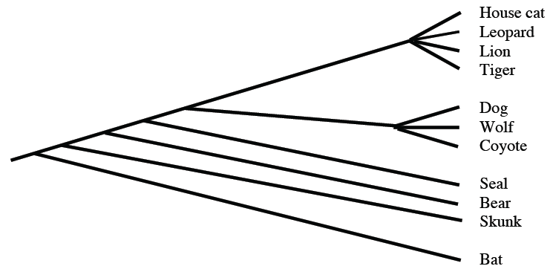**Here’s a sample tree, using groups of carnivores:**

**Family Tree for Cetaceans and Artiodactyls: (4pts)**

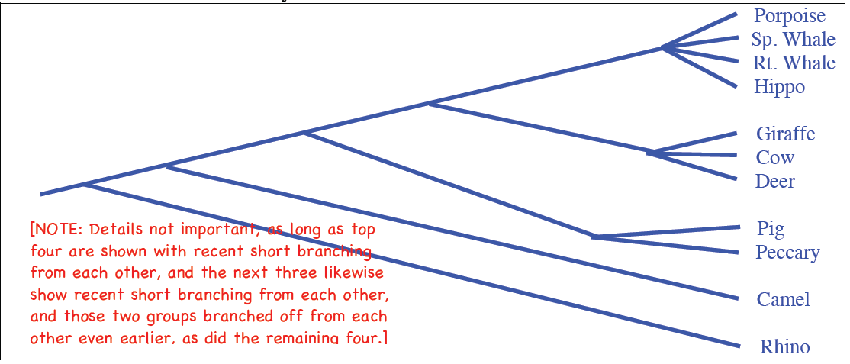

EXTENSION

Now that you’ve done a lot of the hard work, you’ll be happy to hear that there are sophisticated computer programs, with online access by anyone, that can not only compare very large DNA segments (even entire genes) between many different species, but can also draw branching “family trees” based on those differences, showing which groups are most closely related (most recently branched from a common ancestor) and those

that are more distantly related (longer branches from common ancestry at an earlier time). Different genes may give slightly different results, but overall, looking at many genes and many representatives of each group, a fair amount of consensus has emerged, generally consistent with the small sampling that you’ve looked at here. In fact, cetaceans and artiodactyls are now tentatively combined in the single order “Cetartiodactyla.”

If you would like to use those online tools to compare and draw trees for any particular group of animals, try the Tutorial lesson: “**Investigating Evolutionary Questions: Using online Molecular Databases**” at [http://www.indiana.edu/~ensiweb/lessons/p.tut.db.html](http://www.indiana.edu/%7Eensiweb/lessons/p.tut.db.html)