Cells, Heredity, and Classification
Notes 3-1

I. Gregor Mendel - A monk who studied pea plants in a monastery in the mid 1850's and
is known as the "father of heredity/genetics".
A) Heredity- Passing of traits from parent(s) to offspring
B) Mendel's terms and findings
1) Characteristic - A feature that has different forms in a population (hair
color, skin tone, etc.)
2) Trait- Different forms of a characteristic (Red hair, brown hair, black
hair, blonde hair)
a) Dominant Trait- is always expressed if present
(Purple + White = Purple (Purple is the dominant trait))
b) Recessive Trait- only expressed if the dominant trait is NOT
present or dominant trait will mask recessive trait
(Purple + White = Purple (White is the recessive trait))
(White + White = White (White is the recessive trait))
3) 3:1 Ratio = Mendel found when he made the crosses below, he always
came up with a 3:1 ratio of dominant traits to recessive traits

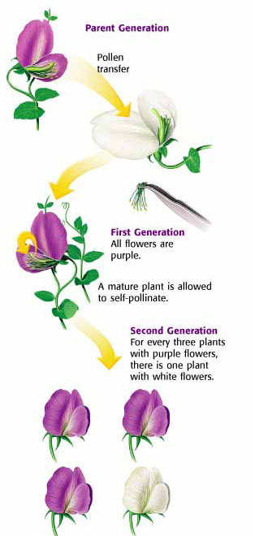

3 Purple (dominant trait) : 1 White (recessive trait)

