Cells, Heredity, and Classification
Notes 3-2

II. Modern Genetics
A) Gene- One set of instructions for an inherited trait (get one set from mom and
one set from dad)
1) Allele- One of the alternative forms of a gene that govern a
Characteristic (blonde hair, black hair, brown hair, red hair)
B) Phenotype- An organisms appearance
C) Genotype- The entire genetic makeup of an organism or a combination of
genes for one or more specific traits.
1) Homozygous- Having 2 dominant or 2 recessive alleles for a trait
(Tall allele from mom + Tall allele from dad = Tall Tall genotype)
(T from mom + T from dad = TT = homozygous dominant genotype)
OR
(short allele from mom + short allele from dad = short short genotype)
(t from mom + t from dad = tt = homozygous recessive genotype)
2) Heterozygous- Having 1 dominant and 1 recessive allele for a trait
(Tall allele from mom + short allele from dad = Tall short genotype)
(T from mom + t from dad = Tt = heterozygous genotype
D) Punnett Square - Diagram used to show all the possible combinations of
offspring from a set of parents

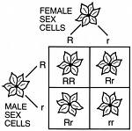

1) Probability- The likelihood that a future event will occur
Genotype: 25% Homozygous dominant (RR)
1:2:1 50% Heterozygous (Rr)
25% Homozygous recessive (rr)
Phenotype: 75% Red (RR and Rr = Red)
3:1 25% White (rr= white)

E) Ways genes interact
1) Law of Dominance- One allele dominates another
2) Incomplete Dominance- Alleles blend together to make something
different than parents (red flower + white flower = pink flower)
3) CoDominance- Both alleles are expressed equally
(Brown horse + White horse = Roan horse)
(Roan = alternating white&brown hairs appear to make hoarse tan)
4) Environmental influence = some genes are turned on or off by changes
in the environment. (Snow shoes turning white in the winter and
brown in the summer)
5) Multiple alleles - More than two alleles for a trait (blood types A, B, O)
6) Polygenetic Traits- Trait that are controlled by more than 2 genes
(eye color is controlled by 4 genes, 2 from mom and 2 from dad)

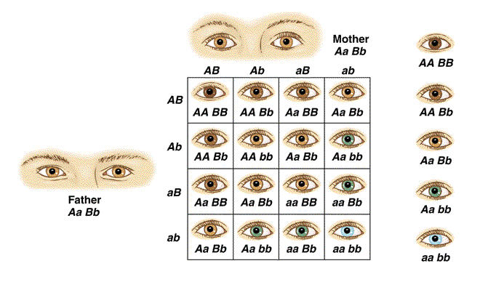 AABB = Dark brown
AABb = Medium brown
AaBb = Hazel eyes
Aabb = Green eyes
Aabb = Blue eyes

