Cells, Heredity, and Classification
Notes 3-3

III. Meiosis
A) Reproduction - the production of offspring
1) Asexual Reproduction- Only one parent is needed and produces a clone
of the parent
a) Mitosis - cell division where a cell copies all of it's structures
and DNA and divides into two identical cells (clones)
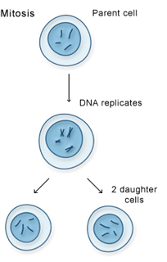
2) Sexual reproduction- Two parents are needed and produce offspring
different than parents
a) Homologous Chromosomes - Chromosomes that contain the
same genes and have the same structure and pair up in the
cell. (In humans, 23 chromosomes from mom and 23
chromosomes from dad = 46 chromosomes which is
23 homologous pairs)
b) Meiosis- Cell division where the number of chromosomes is
decreased by 1/2 and shuffled to form sex cells that have different combinations of genes form the parent. When sex cells come together the full complement of genes reoccurs.
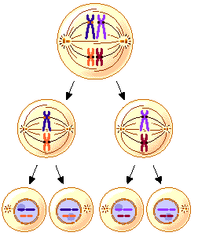
c) Sex Chromosomes - Chromosomes that determine sex of
offspring.
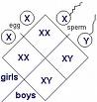
In humans, the male determines the sex of the baby.

d) Sex-linked disorders - Disorders carried on the sex chromosomes, usually on the X chromosome. Most are recessive traits.
1) Males have more often than females because males only
have one X chromosome and, therefore, only need
to get the infected gene from mom to have disorder.
Females need to get infected gene from both parents
to have disorder. If only have one infected gene
they are a carrier and may pass it on to their offspring.
e) Pedigree- A diagram created by a genetic counselor to show the
occurrence of a genetic disorder through a family and to
predict the chance of having a child who will be infected.

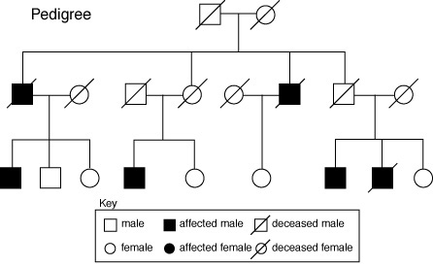
f) Selective Breeding- Organisms with desired traits are selected
and mated to produce offspring with desired traits. (Dog
breeds, most of our fruits and vegetables, most of our
flowers)

